

**DAV PUBLIC SCHOOL**

**ITPS, BANHARPALI**

**SCHOOL UNIFORM**

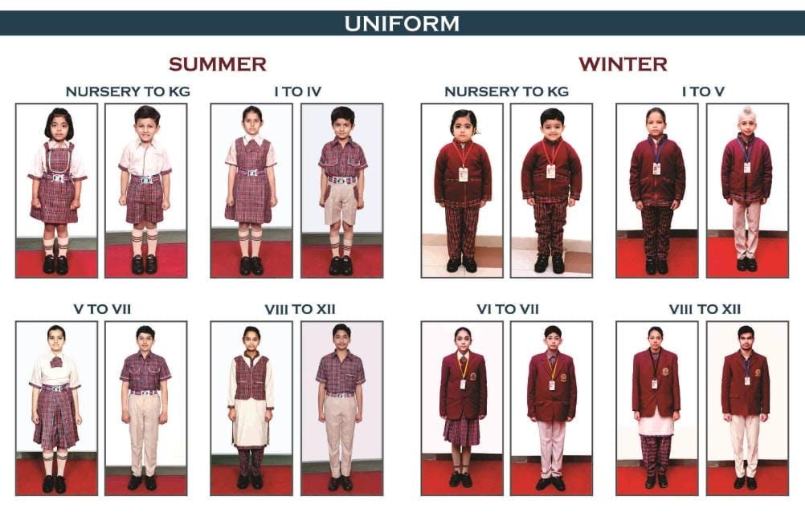

**DIFFERENT HOUSES AND THEIR DRESSES**



**S**

**A**

**T**

**P**

**U**

**R**

**A**

**V**

**I**

**N**

**D**

**H**

**Y**

**A**



**A**

**R**

**A**

**V**

**A**

**L**

**I**

**H**

**I**

**M**

**A**

**L**

**A**

**Y**

**A**